RE: *Bonnie Bornhofen et al. v Jordan Sharpe et al., Case No: 2020SV0336, State Court of Fayette County, State of Georgia*

Date of Crash: October 10, 2018

Date of Birth: *Bonnie Bornhofen:* April 2, 1958 [60 years old at time of crash]

**Background Facts**

On October 10, 2018, at about 4:02 pm Bonnie Bornhofen was the restrained driver of a 2002 Acura MDX SUV that was stopped in the westbound left turn only lane of Kelly Dr., at the intersection of Hwy 74, Peachtree City, Georgia when she was struck from the rear without any prior warning by a 2003 Hyundai Elantra 4DR sedan, driven by Jordan Sharpe. The images below depict the police diagram and the subject vehicles post-collision:

**Police diagram, Ms. Bornhofen’s Acura is labeled “Vehicle # 2”**

**(the diagram incorrectly labeled the subject left turn only lane as a straight/left turn lane)**

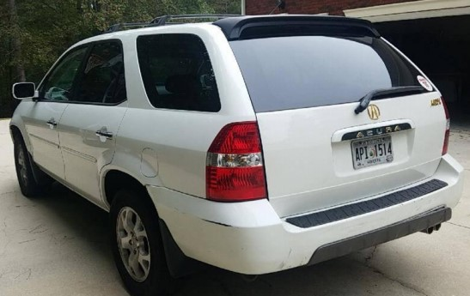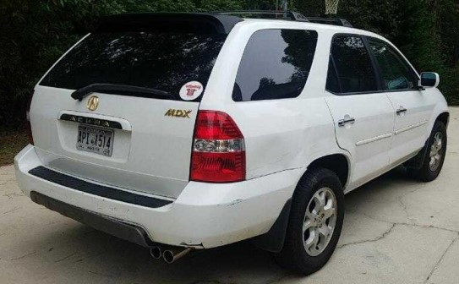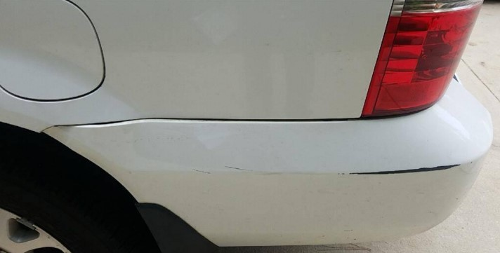

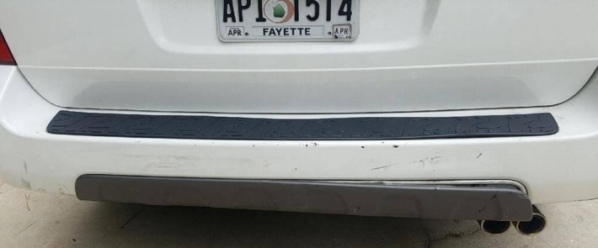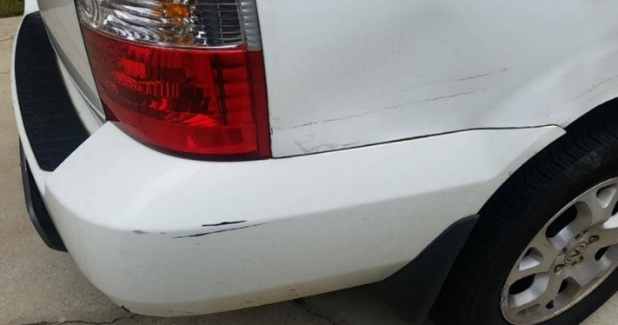

**Ms. Bornhofen’s Acura, post-collision**

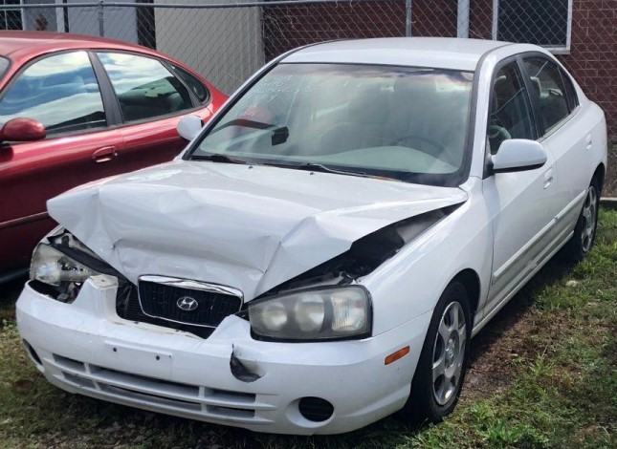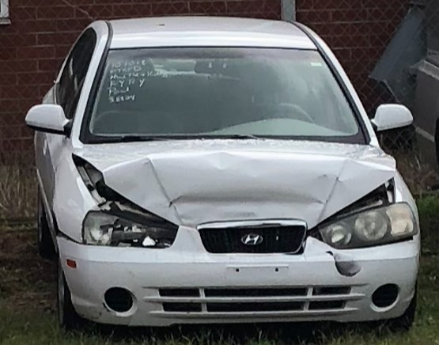

**Hyundai, post-collision**

The damage estimate for the Acura amounted to about $828 and indicated replacement was required for the rear bumper and step. There appears to be some possible damage on the left rear quarter panel as seen in the provided photos, but no mention of it was in the provided damage estimates. The Acura was towed from the scene.

No damage estimate was provided for the Hyundai for review. The provided photos show damage to front bumper cover, grille, both front lighting assemblies, and the hood. The upper section of the radiator appears to have been pushed rearward as well. The Hyundai was towed from the scene, and no air bag deployment occurred.

*Post-crash history*

At the time of the crash, Ms. Bornhofen was stationary, facing forward and fully restrained. The impact caught her by surprise, and she was unbraced. Her whole body was thrown forward, whipping her neck and she felt a tearing sensation starting at her ‘tailbone’ going up through her back. She was unable to move so stayed put until EMS arrived. Ms. Bornhofen was placed on a backboard and transported to the Piedmont Lafayette Hospital ED where she complained of pain in her head, neck, and entire back.

Ms. Bornhofen underwent X-rays of the cervical and thoracic spine which were negative for acute osseous abnormality. She was diagnosed with acute cervical spine strain, thoracic myofascial strain, provided with prescriptions for Flexeril and Ibuprofen, and released home.

On October 24, 2018, 14 days after the crash, Ms. Bornhofen commenced therapeutic modalities with Dr. Eric Shearer (chiropractic). Ms. Bornhofen underwent therapy through February 11, 2020.

On October 26, 2018, Ms. Bornhofen presented to Kelly Callis PA to Dr. Michael Obenshain (internal medicine) with severe headaches, pain in her neck, and back, she had tingling down her arms, difficulty standing and trouble sleeping. Ms. Callis diagnosed neck strain, thoracic strain, low back strain, cervical radiculopathy; recommended physical therapy and rest.

On October 30, 2018, Ms. Bornhofen commenced physical therapy at ProHealth; she was having blurred vision in addition to headaches, neck, and back pain. Ms. Bornhofen underwent at least 100 sessions over a period of two and a half years.

On December 14, 2018, Ms. Bornhofen presented to Dr. David Brcka (orthopedic surgery) with pain in her cervical, thoracic, and lumbar spine/groin. Dr. Brcka recommended obtaining cervical and lumbar MRIs. Ms. Bornhofen declined anti-inflammatory pain medication.

On December 28, 2018, Ms. Bornhofen underwent an MRI of the lumbar spine which revealed: at L2-3, minor central canal narrowing due to mild annular bulge with midline annular fissure and mild endplate spurring; at L3-4, mild central canal stenosis due to mild annular bulge, mild endplate spurring, ligamentum flavum hypertrophy, and mild facet arthropathy; at L4-5, mild central canal stenosis and mild left neural foraminal stenosis due to mild broad-based left sided disk bulge/protrusion associated with annular fissure abutting the descending left L4 nerve root, mild endplate spurring, ligamentum flavum hypertrophy, and facet arthropathy.

On January 14, and February 8, 2019, Ms. Bornhofen returned to Dr. Brcka with left hip pain. He ordered X-rays and an MR arthrogram of the left hip and referred Ms. Bornhofen for surgical consultation.

On February 22, 2019, Ms. Bornhofen underwent the left hip MRI which revealed: a tear of the acetabular laterally and anteriorly without displaced labral fragment; Grade II or III chondromalacia affecting the articular surfaces of the hip superiorly and laterally; and mild trochanteric bursitis.

On March 20, 2019, Ms. Bornhofen presented to Dr. Jon Hyman (orthopedic surgery) to discuss treatment for the left hip.

On May 7, 2019, Dr. Hyman performed a left hip steroid injection.

On July 1, 2019, Ms. Bornhofen presented for an ophthalmology evaluation secondary to persistent blurred vision (distance). Examination revealed peripheral pterygium (surfer’s eye-progressive), bilateral presbyopia and bilateral hypermetropia.

On July 5, 2019, Dr. Hyman repeated the left hip steroid injection.

**On December 31, 2019, Dr. Hyman performed a diagnostic left hip arthroscopy with labral repair, synovectomy, femoral osteoplasty and Greater Trochanteric bursectomy.**

Ms. Bornhofen participated in post-op physical therapy (she also had a slip and fall incident and re-injured the left hip which improved with continued therapy).

On March 17, 2021, Ms. Bornhofen presented to Dr. Erik Bendiks (orthopedic spine surgery) with persistent neck pain, stiffness (particularly positional), headaches and a dull ache in her lower back, aggravated by bending down and with an episode of numbness and tingling in both legs. Ms. Bornhofen underwent X-rays which remained negative for osseous abnormality. Dr. Bendiks diagnosed cervical myelopathy, cervicalgia, lumbago with radiculopathy, and ordered MRIs of the cervical and lumbar spine.

On March 21, 2021, Ms. Bornhofen underwent the MRIs. The cervical spine study revealed: anterolisthesis at C3-4 with 1 mm retrolisthesis at C6-7; at C3-4, posterocentral protrusion type disk herniation (6 mm) compressing the thecal sac; at C4-5 and 5-6, disk bulge compressing the thecal sac; at C6-7, disk bulge with right paracentral protrusion type disk herniation compressing the thecal sac causing moderate right neuroforaminal narrowing.

The lumbar spine study revealed: at the L2 vertebral body, hemangioma; at L3-4, asymmetric disk bulge compressing the thecal sac and causing neuroforaminal narrowing; at L4-5, broad based posterior and left paracentral disk herniation (7 mm) with annular tear compressing the theca sac causing bilateral neuroforaminal narrowing; at L5-S1, disk bulge with annular tear compressing on the ventral epidural fat.

On March 25, 2021, Ms. Bornhofen returned to Dr. Bendiks. He additionally diagnosed cervical and lumbar disk herniations, lumbosacral and cervical facet arthropathy; and referred Ms. Bornhofen to pain management to discuss injection therapy for the cervical and lumbar spine.

On April 5, 2021, Ms. Bendiks presented to Dr. Daryl Figa (physical medicine and rehabilitation). He prescribed Frotek topical cream and recommended two sets of bilateral C4-6 platelet rich plasma (PRP) epidural injections to treat the lumbar spine at L4 with bilateral PRP facet injections at L4-5 and L5-S1; and bilateral PRP cervical medial branch block injections at C4-6.

On November 22, 2021, and April 8, 2022, Dr. Figa reiterated recommendations for injection therapy to treat persistent pain in the neck and lower back.

On July 18, 2022, Ms. Bornhofen underwent the first set of cervical PRP medial branch block injections at C4-6 (providing 100% relief for 2-3 days); and bilateral L4-5and L5-S1 facet PRP injections with no relief.

(Dr. Figa also prescribed Ultram 50 mg, and Metaxalone 800mg)

On August 30, 2022, Dr. Figa recommended pursuing bilateral radiofrequency facet neurotomies at C4-6 and deferred Ms. Bornhofen to Dr. Bendiks to discuss further treatment options for the lumbar spine.

On October 19, 2022, Dr. Figa performed bilateral C4-5 and 5-6 cervical facet medial branch radiofrequency neurotomies.

Ms. Bornhofen’s neck pain persisted and began radiating into the right shoulder. The lower back pain also persisted.

On October 21, 2022, Ms. Bornhofen updated the lumbar MRI which revealed: at L1-2, posterocentral disk herniation with annular fissure and cranial migration (5 mm) posterior to the L1 vertebra compressing the thecal sac; at L2-3, posterocentral disk herniation with caudal migration (3 mm) posterior to the L3 vertebra compressing the thecal sac; at L3-4, disk bulge compressing the thecal sac causing bilateral neuroforaminal narrowing; at L4-5, broad based posterior protrusion compressing on the thecal sac and causing bilateral neuroforaminal narrowing; at L5-S1, disk bulge compressing on the ventral epidural fat.

On January 24, 2023, Ms. Bornhofen returned to Dr. Bendiks. He discussed undergoing a C3-6 anterior cervical discectomy and fusion (ACDF) and bilateral L4-S1 facet injections and bilateral L4 epidural injections.

On March 2, 2023, Dr. Figa performed bilateral L4-5 and L5-S1 facet joint injections without relief.

On April 27, 2023, Dr. Figa performed bilateral L4 transforaminal epidural steroid injections without relief.

On June 28, 2023, Dr. Bendiks recommended undergoing a C3-5 artificial disk replacement and a C5-6 ACDF and discussed chronic pain management for the lumbar spine.

On July 21, 2023, Dr. Figa recommended pursuing L3-S1 diagnostic medial branch block injections.

On July 18, 2023, Ms. Bornhofen updated the cervical spine MRI which revealed: at C6-7, disk degeneration (worse on the right) with mild secondary bone marrow edema of the right lateral endplates of both vertebrae, bone spurring causing moderately severe right foraminal stenosis; at C5-6, moderately severe disk degeneration and narrowing, wide combination of disk bulge and spur which causes deformity of the thecal sac extending to the cord (without compression), mildly narrowed bilateral foramina secondary to lateral spurring; at C3-4, small posterior and central disk protrusion causing deformity of the thecal sac, and mild disk degeneration.

On August 11, 2023, Ms. Bornhofen presented to Franklin Hepfer PA-C with neck pain, headaches, and lower back pain. She also reported changes to sensation in her right upper extremity. Mr. Hepfer diagnosed cervical arthritis, cervical osteophyte/disk degeneration, and cervical kyphosis. Ms., Bornhofen was referred to physical therapy.

On October 5, 2023, Ms. Bornhofen engaged in a further course of therapeutic modalities, with Dr. Raymond Infanti (chiropractic) and Jeremy Cugle (PT). Pain persisted in her neck (more so on the right) with associated numbness in the right arm, and she had constant pain in her lower back.

On November 12, 2023, Ms. Bornhofen underwent a functional capacity evaluation at Highland Park Physical Therapy which revealed: Height: 5 ft 5 inches, weight: 132 lbs.

*Pre-crash medical history*

Ms. Bornhofen was in a prior traffic crash with a resultant neck injury (cervicalgia).

She underwent occasional chiropractic, massage, and physical therapy for neck and back pain, a right ankle sprain, muscle strains/muscle aches and stiffness in her arms, legs, and torso).

Ms. Bornhofen was asymptomatic at the time of the subject crash.

**Documents Reviewed**

* Complaint
* Bonnie Bornhofen, deposition, March 10, 2021
* Peach Tree City Fire Rescue
* First Georgia Physician’s Group
* Art of Life Chiro (prior/post), Dr. Shearer
* Ortho Atlanta, Dr. Brcka (prior/post)
* Advanced Orthopedic Surgery, Dr. Hayman
* ProHealth Physical Therapy (prior/post)
* Georgia Spine and Orthopedics, Dr. Bendiks
* Elite Radiology of Georgia, MRIs
* Surgery Center of Rosswell, neurotomy
* Advanced Eye Centers
* American Health Imaging, cervical MRI
* Orthopedic Surgery and Sports Medicine, Dr. Hyman
* Highland Park Physical Therapy FCE report
* Infanti Chiropractic
* Maryland Brain, Spine + Pain
* Northside Hospital Atlanta, left hip MRI
* Bornhofen complaint
* Demand letter
* Peachtree City Police traffic crash report
* Deposition transcript of (Robert Bornhofen (March 10, 2021)
* Deposition transcript of Jordan Sharpe (March 12, 2021)
* Deposition transcript of Dr. Lu with exhibits (April 10, 2024)
* Deposition transcript of Dr. Hyman (November 10, 2021)
* Deposition transcript of Dr. Negrin (March 26, 2024)
* Two damage estimates-Acura
* Dr. Lu’s case file
* Piedmonte Fayette ER medical records-Ms. Bornhofen
* ProHealth medical records-Ms. Bornhofen
* 34 digital images (Acura, Hyundai, satellite views)

*Reconstruction:*

According to the police report it was daylight, raining and the road was wet. The speed limit on Kelly Dr. was 30 mph.

Ms. Bornhofen, deposed on March 10, 2021, testified that she was stopped for a red light, did not have any vehicles stopped ahead of her and the last time she checked her rearview mirror there weren’t any vehicles behind her. She was watching and waiting for the light to turn green and all of a sudden, she was struck from behind. She did not know what had happened and she had a sensation of her whole body being thrown forward. The impact was very hard, her whole body was thrown forward and her head snapped. She looked in her rearview mirror and there was a car a ways back behind her and it was smashed up. She did not have any idea how fast the Hyundai had been going when the impact occurred. Her Acura did not have any prior damage to it of which she was aware.

Mr. Bornhofen, deposed on March 10, 2021, did not provide any crash reconstruction related information.

Ms. Sharpe, deposed on March 12, 2021, testified that she was on her way to a new job, was a little behind her schedule and was feeling a little bit pressed to get to work on time. She had turned onto Kelly Dr. from a side street, only had a short distance to go before she would arrive at the intersection with Hwy. 74, and estimated her maximum speed as 15 mph. She arrived at the intersection and came to a stop in the left turn lane about one-half of a car length behind the Acura, which had a vehicle stopped ahead of it. She changed out of her school uniform shirt into her work shirt while waiting at the stop light. The light turned green after about one minute, they all began to go forward, she looked down to put her school uniform shirt in the passenger seat, and she still had her foot on the accelerator. Ms. Bornhofen slammed on her brakes and the Hyundai came to a stop. She hadn’t been paying attention and didn’t realize the Acura had done so, she struck it at no more than 10 mph, and she did not know if she ever put her foot on the brake before the impact. She did not think that her Hyundai had been in any previous crashes, it did not have any exterior damage prior to the subject crash, and it was deemed a total loss.

Dr. Lu, deposed on April 10, 2024, testified that she did not complete a formal report for this case, but did complete a notes document. It was her opinion that Ms. Bornhofen did not sustain any loading or forces to her left hip as a result of the subject crash that would have resulted in the alleged hip injury. There wasn’t any evidence that a forward impact to the left knee occurred and as such there wasn’t any compaction loading to the left hip joint. For Ms. Bornhofen’s knees to hit the dashboard she would have had to be sitting very close to the dashboard with less than one inch of space between the dashboard and her knees. The photos and damage estimate of the Acura’s rear bumper damage indicated that the impact was less than 10 mph in the subject underride frontal collision which may have had some offset, but no angle to the impact. They were able to determine the crush width and maximum crush depth (1.04’) to the front of the Hyundai by scanning an exemplar Hyundai (refer to scan images contained in the summary of her notes document below) and used the data to calculate an impact speed and delta V on both vehicles. The Acura was at a complete stop and the impact speed of the Hyundai was between 8.2 and 11.7 mph. The delta V for the Acura was 4 to 5.7 mph, and the forces were in the range of 3 to 4.3 g. The rear of the Acura did not have any structure that would have resulted in the hole in the driver’s side of the Hyundai’s front bumper cover due to the impact and she determined that it had not occurred in the subject crash. The photos of the Acura showed some possible deformation to the right rear quarter panel that was either pre-existing damage, it was shadows or the camera angle when the photo was taken since no mention of damage in that area was in the damage estimates. The driver’s seat head rest would have provided sufficient protection and prevention of Ms. Bornhofen’s head and neck from extending over the top of it. If Ms. Bornhofen was wearing her seat belt correctly, there would not have been any interaction with it and her left hip joint. The forward flexion to her thoracolumbar spine was no more than two to three inches, which was well within the physiological range of motion that would be experienced in daily, routine or work activities performed by Ms. Bornhofen. The forward flexion of her cervical spine was about one to one and one-half inches and also was well within the physiological range of motion that would be experienced in daily, routine or work activities performed by Ms. Bornhofen.

(Studies involving the use of human volunteers, cadavers, and anthropomorphic test devices/ATDs were contained in her project file folder.)

Dr. Hyman, deposed on November 1, 2021, testified that he was a board-certified orthopedic surgeon in the state of Georgia. He did not have an opinion on the causation of Ms. Bornhofen’s injuries, but the subject crash was the presumptive cause, based on what she reported. He did have a limited-in-scope opinion that the subject crash caused her to start experiencing pain in her hip due to some underlying condition that she had. Generally speaking, a rear-end collision would not cause the underlying conditions but could aggravate them and underlying conditions could also make one more predisposed to injury or aggravation.

Dr. Negrin, deposed on March 26, 2024, testified that he was retained as an expert in the case and expected to testify that Ms. Bornhofen did not suffer an acute injury in the subject crash. He did not complete a formal report of his findings but did have his notes documented. His opinions were that Ms. Bornhofen’s left hip problem was a chronic pre-existing condition that was not causally related to the subject crash, and he was not able to explain how the subject crash could have caused her injury. There was inconsistency in reporting some of the facts involving the subject crash based on either misrepresentation by the doctor who wrote the notes or by Ms. Bornhofen. He also concluded that she most likely had an acute strain of the cervical spine and her shoulder musculature, which was not a permanent anatomic injury, and she did not have any acute exacerbation of her pre-existing neck or back conditions. The doctor notes he read did not discuss the crash forces Ms. Bornhofen would have experienced and only stated the damage to her vehicle was minimal. Since there was no damage to the vehicle, there was no significant force placed on Ms. Bornhofen’s body.

The police report stated that both subject vehicles were at a stop on Kelly Dr. for a red light and the Acura was the lead vehicle. When the light turned green, Ms. Sharpe began to go forward and bent down to get something in her passenger side floorboard. She felt the impact and realized that the Acura ahead of her had not moved yet. Ms. Sharpe caused the crash due to completing an improper start.

**Opinions of defendant’s expert, Dr. Lu**

Dr. Lu provided a 76-page notes file that contained her conclusions regarding the reconstruction of the subject crash. She did not provide any opinions on Ms. Bornhofen’s injuries.

Dr. Lu’s substantive conclusions can be summarized as follows:

* In her momentum & energy and sensitivity analyses:
  1. Acura
     + Was at a complete stop at the time of impact.
     + The post impact speed was 4.9 mph.
     + The delta V range was 4 to 5.7 mph.
     + The peak acceleration range was 3 to 4.3 g.
  2. Hyundai
     + The impact speed range was 8.2 to 11.7 mph.
     + The post impact speed was 2.4 mph.
     + The delta V range was 6.3 to 8.9 mph.
     + The peak acceleration was 5.9 g.
  3. The restitution value used was 0.25.
* Her notes indicated that the weather and lighting conditions at the time of the subject crash were daylight, clear and dry, which was different than the information contained in the police report which indicated it was daylight raining and wet.
* Work product images contained in the file included:

*Crash Analysis:*

Dr. Lu estimated the crush depth at 12+ inches. A widely used crash simulation program[1] is capable of modeling deformation and depth of penetration or maximum engagement during a collision. By overlapping the damage between scale models of the Hyundai and the Acura as observed in the photos and estimated by Dr. Lu, I can model the subject crash to determine a closing speed estimate, which will in turn, estimate an approximate speed change or delta V imparted to the Acura in the crash by using a momentum, energy and restitution (MER) analysis, and then matching these results to the physical and other evidence as well as estimate the amount of deformation (crush).

An impact speed of 15 mph from the Hyundai would have resulted in a delta V in the Acura of approximately 7.0 mph, with a peak vehicle acceleration for the impact of approximately 5.1 g. Deformation (crush) in the Hyundai is about 10 inches, slightly under Dr. Lu’s crush measurement.

An impact speed of 20 mph from the Hyundai would have resulted in a delta V in the Acura of approximately 8.9 mph, with a peak vehicle acceleration for the impact of approximately 6.4 g. Deformation (crush) in the Hyundai is about 12 inches, this is fairly consistent with deformation seen in the photos of the Hyundai and Dr. Lu’s crush measurement.

Deformation (crush, overlap or depth of penetration) between the Hyundai and the Acura is shown below for all simulations including Dr. Lu’s maximum calculated impact speed of 11.7 mph which only yielded a deformation of about 6.5 inches. Deformation in the Acura is approximately 1 inch in all cases:

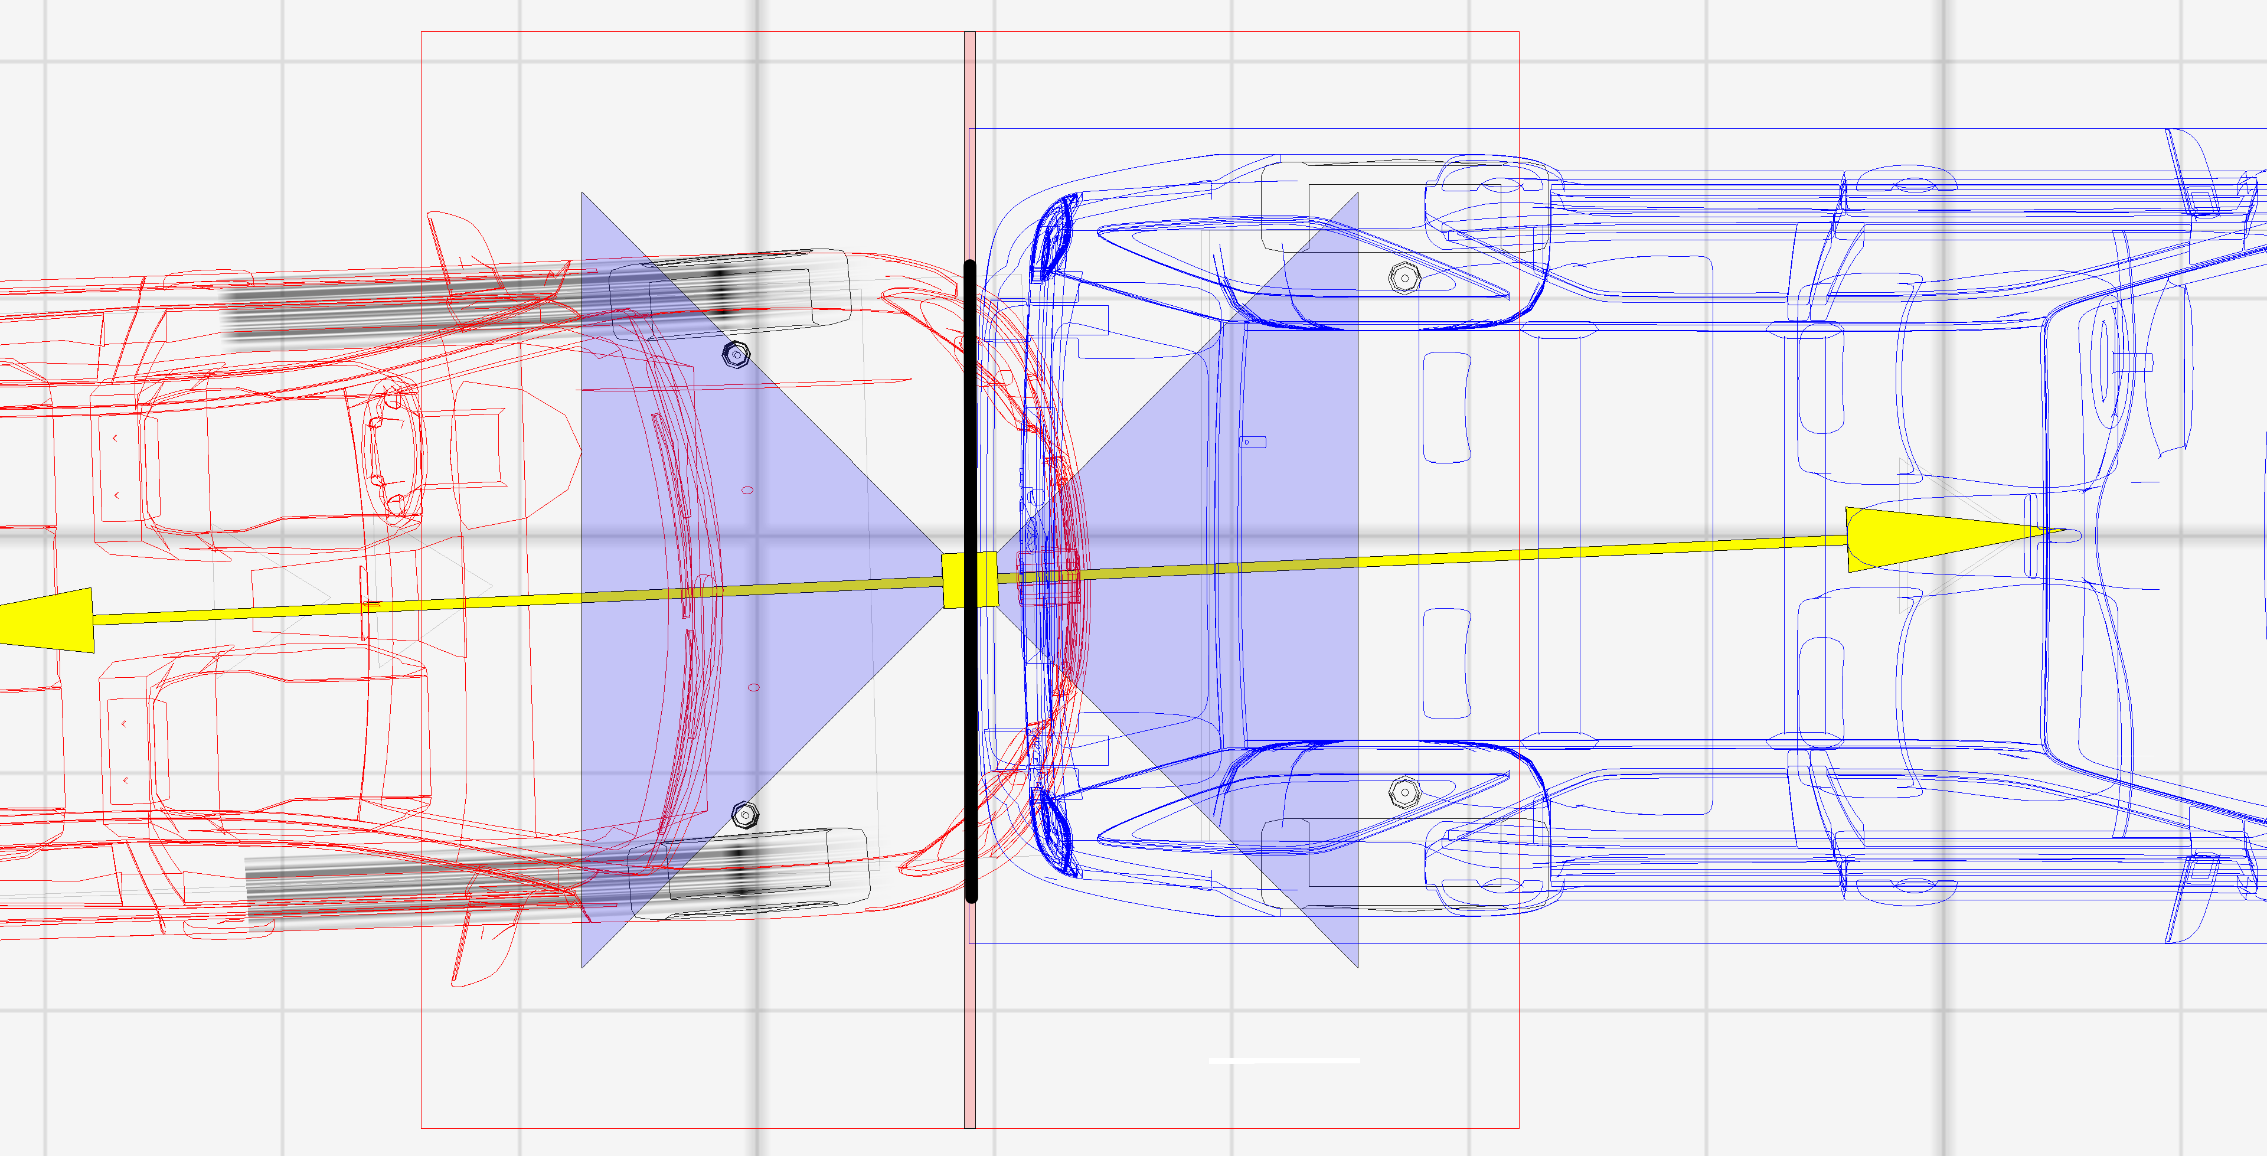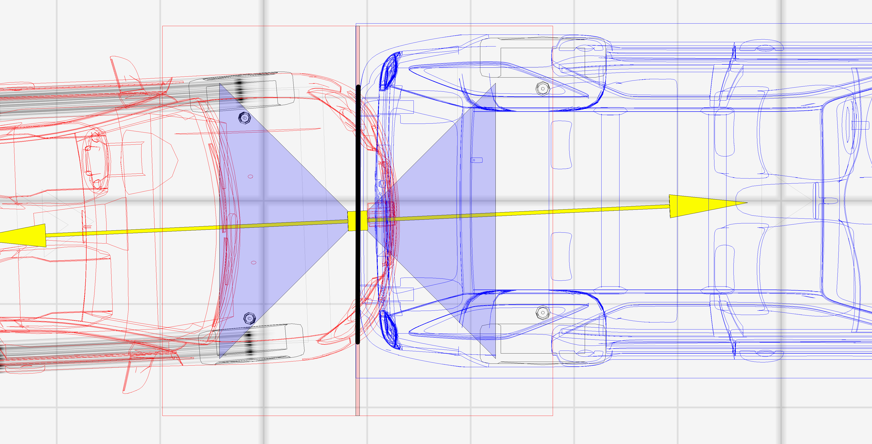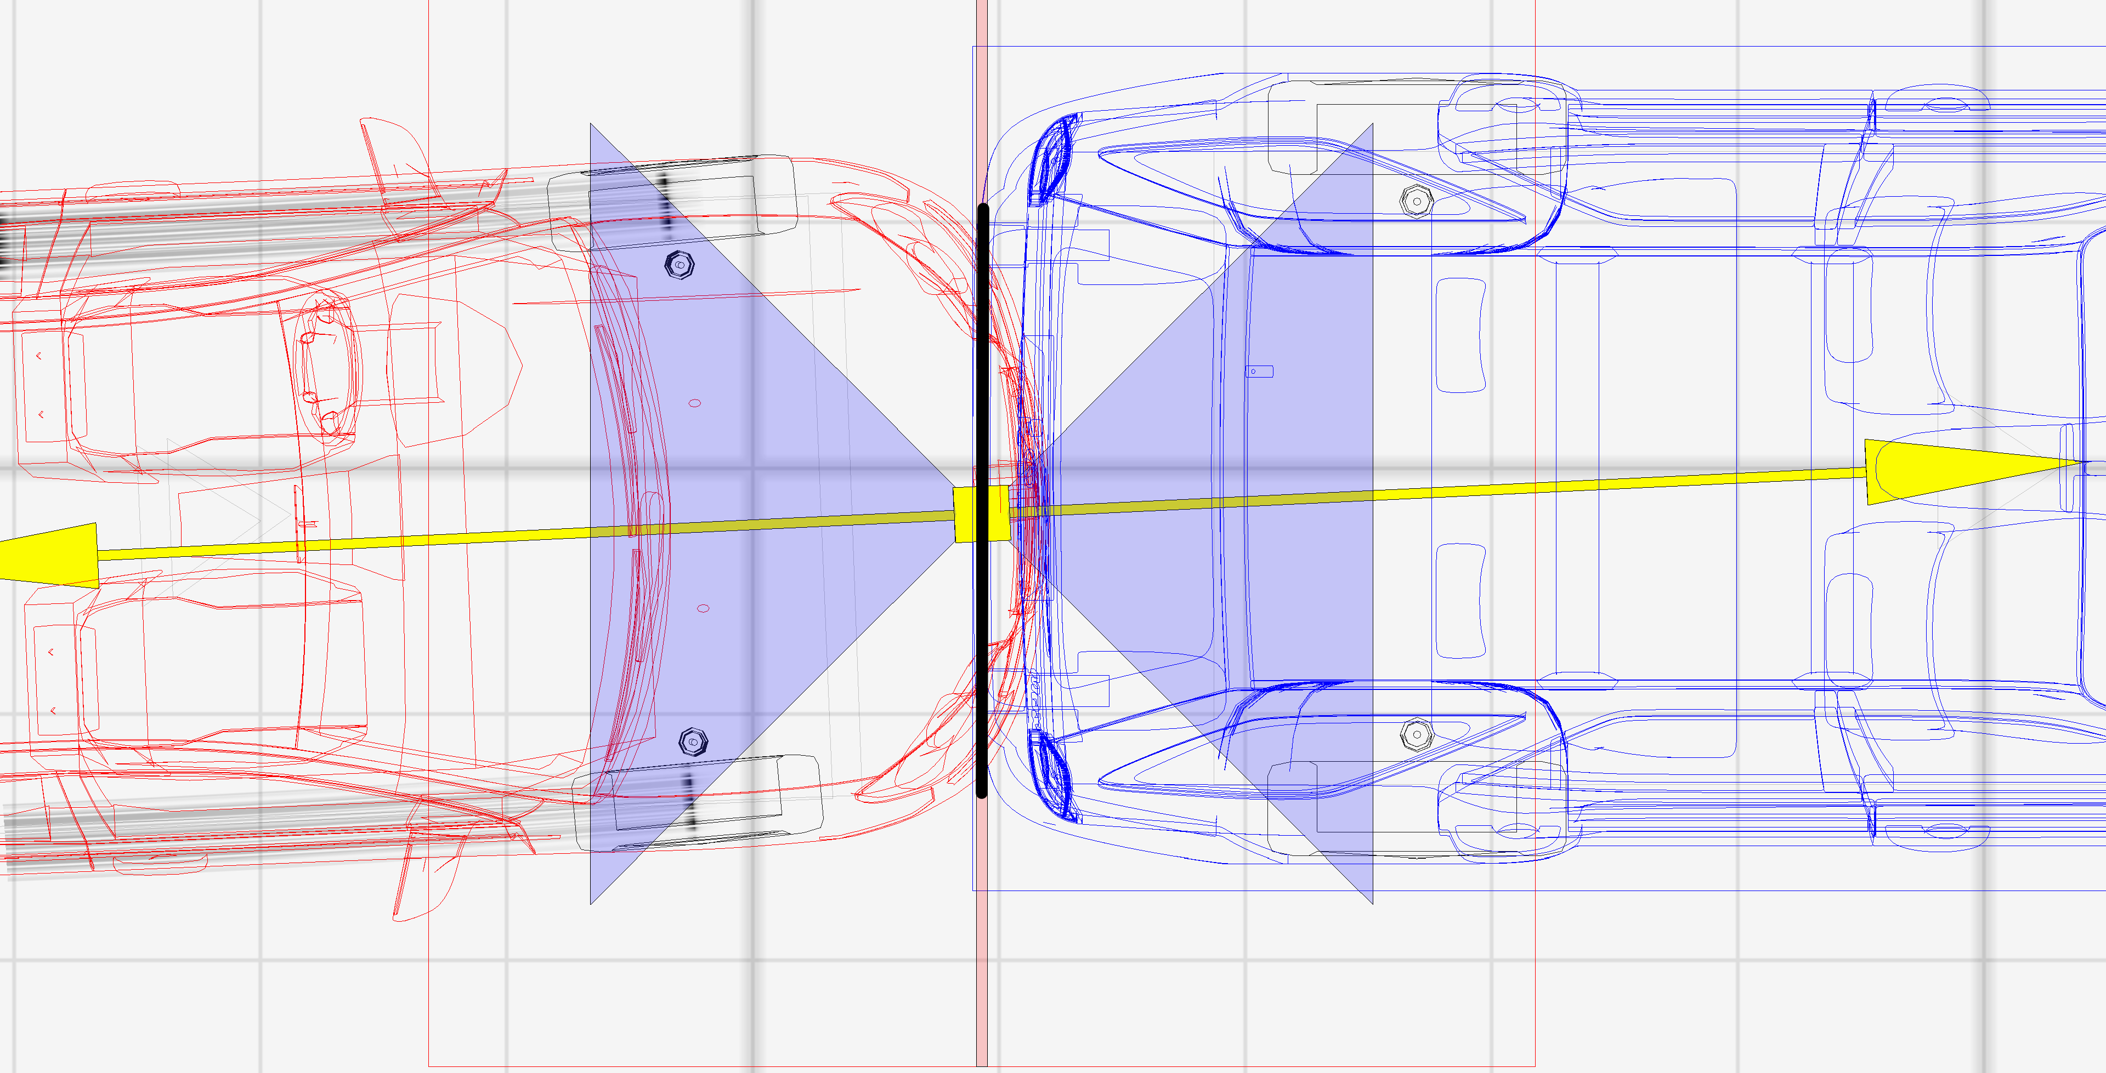

**20 mph impact**

12 inches of deformation

**11.7 mph impact**

6.5 inches of deformation

**15 mph impact**

10 inches of deformation

**Simulated impact depth of penetration (crush, overlap or maximum engagement) marked by the vertical black line. Acura is the vehicle on the right in blue. Impulse vector shown by yellow arrows.**

1. Virtual Crash 5, vCrash America Inc.